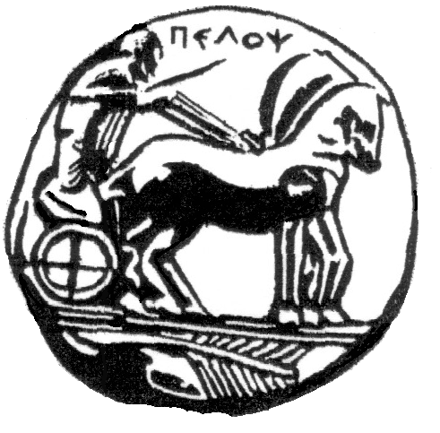
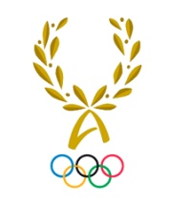
UNIVERSITY OF PELOPONNESE
INTERNATIONAL OLYMPIC ACADEMY

MASTER’S DEGREE PROGRAMME
“OLYMPIC STUDIES, OLYMPIC EDUCATION, ORGANIZATION AND MANAGEMENT OF OLYMPIC EVENTS”

APPLICATION 2016-2017

TO THE SECRETARIAT OF THE MASTER’S DEGREE PROGRAMME

Personal Details
Surname
First name
Date of birth |  | ID card/Passport:
Address
Telephone number: |  | Mobile:
E-mail:

I declare that I apply for the Master’s Degree Programme “Olympic Studies, Olympic Education, Organization and Management of Olympic Events” for the academic year 2016-2017. All required documents are attached to this application and the relevant information is provided.

Higher Education

Institution*:
Department:
Degree:
Years of attendance: |  | Grade:

Institution*:
Department:
Degree:
Years of attendance: |  | Grade:
*name of institution, type, place and country

Secondary Education

Institution:
Main course of study:
Years of attendance: |  | Grade:

Knowledge of Languages

Language | Certificate | Level of Knowledge

Publications (if existed)

Professional Experience*

*Include the title of the job, the duration, the employee and his/her contact details. Include also your current employment.

Sports career as an athlete (if existed):

Awards in sport:

Motivation
I pursue participation in the Postgraduate Programme for the following reasons:

I’m interested in applying for a scholarship if available.
(institutions which will provide scholarships will define the requirements)

I’m interesting in the programme regardless the outcome of the scholarships.
(by checking this you won’t be eliminated from the process if the application for scholarship is not
successful)

Date __________________ Signature ________________

